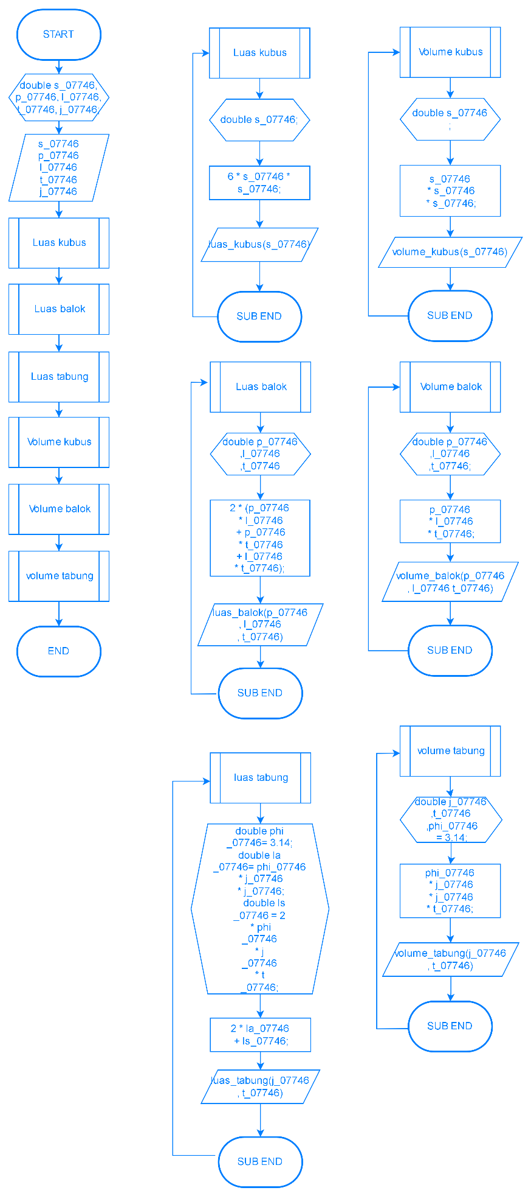

#include <iostream>

using namespace std;

int main () {

double s_07746, p_07746, l_07746, t_07746, j_07746;

double luas_kubus_07746, volume_kubus_07746, luas_balok_07746, volume_balok_07746, luas_tabung_07746, volume_tabung_07746;

const double phi_07746 = 3.14;

cout << "===Program Perhitungan Luas Dan Volume====\n"

"===========Kubus, Balok ,Tabung===========" << endl;

cout << "Masukkan sisi = ";

cin >> s_07746;

cout << "Masukkan panjang = ";

cin >> p_07746;

cout << "Masukkan lebar = ";

cin >> l_07746;

cout << "Masukkan tinggi = ";

cin >> t_07746;

cout << "Masukkan jari-jari = ";

cin >> j_07746;

luas_kubus_07746 = 6 * s_07746 * s_07746;

volume_kubus_07746 = s_07746 * s_07746 * s_07746;

luas_balok_07746 = 2 * (p_07746 * l_07746 + p_07746 * t_07746 + l_07746 * t_07746);

volume_balok_07746 = p_07746 * l_07746 * t_07746;

luas_tabung_07746 = 2 * phi_07746 * j_07746 * j_07746 + 2 * phi_07746 * j_07746 * t_07746;

volume_tabung_07746 = phi_07746 * j_07746 * j_07746 * t_07746;

cout << "=================================================" << endl;

cout << "Luas Kubus = " << luas_kubus_07746 << endl;

cout << "Luas Balok = " << luas_balok_07746 << endl;

cout << "Luas Tabung = " << luas_tabung_07746 << endl;

cout << "==================================================" << endl;

cout << "Volume Kubus = " << volume_kubus_07746 << endl;

cout << "Volume Balok = " << volume_balok_07746 << endl;

cout << "Volume Tabung = " << volume_tabung_07746 << endl;

}}